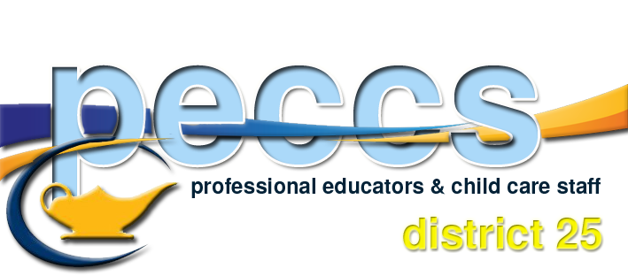

2021-2022 Executive

President Corinne Lassaline
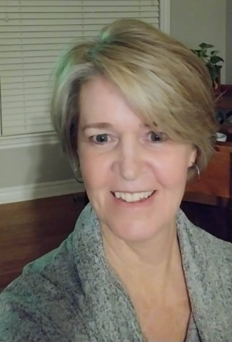
Corinne Lassaline has been employed by the OCDSB since January 2000. During these past 21 years, she has worked within the Adaptive Learning Program, teaching job skill/life skills to adult learners who have developmental disabilities.
Her motto is: Everyone deserves to be a contributing member of society! Corinne joined the PECCS Executive in 2019 and is currently in her second year as president. She feels honoured to be part of such a great executive and membership. It has been a very steep learning curve, going from strikes, into central negotiations, right into a pandemic and onto local bargaining...what a ride!! She looks forward to representing/helping the PECCS members in whatever capacity is needed by each individual and as a membership on the whole.

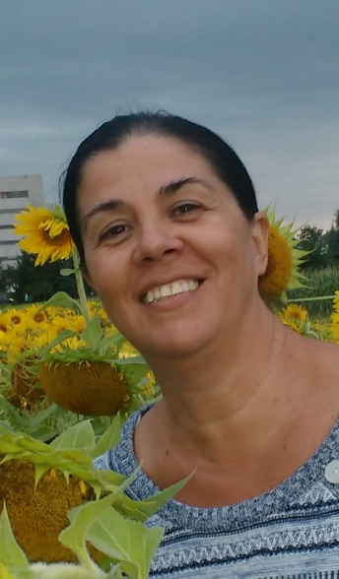
Vice-President Ana Vasquez
My name is Ana Vasquez, I am from Colombia and I immigrated to Canada with my husband and two children in 2005.
I have been enrolled with PECCS and working with OCDSB as a Childcare Assistant for 8 years at 440 Albert St. I have always been passionate about working with children, and love taking care of them, that is why I decided to become a parent volunteer at my children’s daycare in 2007, after being a volunteer for about 2 years a decided to complete my Childcare Assistant course in 2009, since then I was working in almost all sites of the program until I got my permanent position, this is a rewarding opportunity to be working in a diverse environment and supporting the newcomer children and their families.
I am very excited to start my new role as Vice-Principal and be a part of PECCS members & executive committee.
Membership Services Officer Patti Sevigny

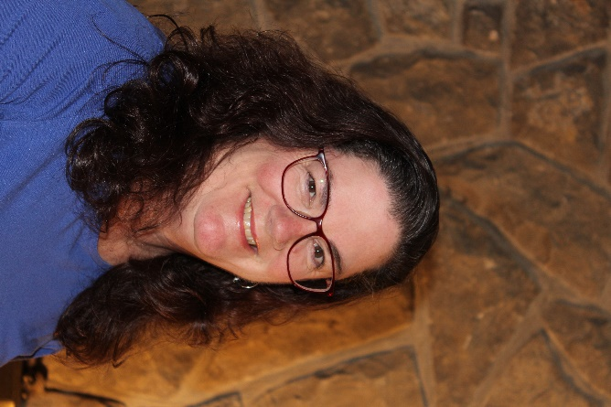
Patti has been a member of PECCS since 2010. She is an LBS instructor in the Academic Upgrading Program by day, and an ESL Literacy instructor two nights a week. Before teaching in the AU program, she taught a Childcare Assistant class in LBS for 6 years. She also enjoyed a term position as a Childcare Supervisor at Confederation Education Center for a year.
She is now retired from a long and rewarding career as a Registered Early Childhood Educator and continues to love her second career of teaching newcomers to Canada. Her passion for seeing her students improve their literacy skills and achieve their goals of independence and employment are what keeps her coming to work every day! In her spare time, Patti enjoys singing and playing her guitar. She writes songs, children’s stories and short stories. She hopes to have a children’s story published in the future. Patti is very excited to be a part of the executive team and looks forward to her new role as the membership services officer.

Communications Officer Angela Hood

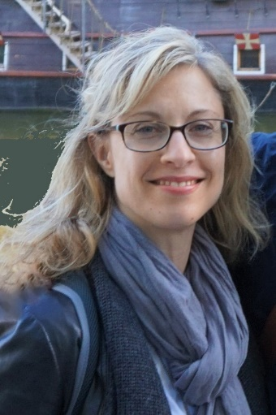
Angela is an ESL/LINC Instructor at OTSS and has been a member of PECCS since 2010. Before teaching with the Board, Angela taught EFL in Mexico and studied corporate communications and public relations. In her spare time, she enjoys salsa dancing and yoga. Angela is honoured to serve her fellow hardworking PECCS members as communications officer.

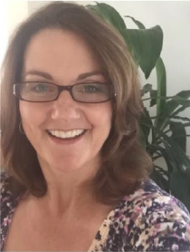
Chief Negotiator Alison Trusty

Alison has been a member of PECCS since 2009. She is currently the Support Instructor with Literacy and Basic Skills. She also teaches in ESL classrooms at night. Prior to these positions, she taught a Child Care Assistant Program within Literacy and Basic Skills. As such, she instructed in class as well as visits our childcare programs to meet with students in their work placements.

She is happy to be representing PECCS in the Chief Negotiator position and hopes to bring an understanding of what PECCS role is to our diverse membership.

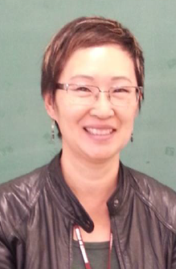
Secretary June Myles

June has been an ESL Instructor with the OCDSB since 2013 and joined the Executive Committee in 2015. Prior to joining the Board, she taught English to public servants in Ottawa and has also taught in Mexico and China. Before she found her way home onto the ESL path, she worked in labour relations, customer service, and retail. She has a Masters in Education from the University of Ottawa and a Bachelor of Commerce from Carleton University. Having studied French, Spanish and Mandarin, she knows personally the challenges of learning a language and takes that perspective into her classroom. She has taught a variety of levels and types of ESL classes (Workplace English, ESL for the Trades). She is currently teaching ESL for Adults with Developmental Delays.

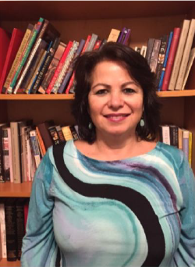
Treasurer Ibtisaam Abboud

Ibtisaam has been in ESL/EFL for about 16 years, teaching overseas, in high school and a couple of specialty courses with private organizations, here in Ottawa.
She has been with OCDSB for 7 years and with the Union for 5 of them. Ibtisaam teaches English for Academic Purposes in the morning, and Academic Test Preparation at night, at 440 Albert St. She loves what she does because it’s so rewarding and it makes such a difference in so many students’ lives. Her time with PECCS has been equally gratifying since she has seen what a difference it has made in many of our members’ lives - especially after getting benefits!
In her spare time, she likes to bake, read, swim and work in her garden, in the summertime.

Health and Safety Officer (non-voting) Amy Lapensee

My name is Amy Lapensee. I am with the Adaptive Program at Albert Street Centre. I am an Instructor Assistant. I have been with the program since November 2004. I look forward to being your site health and safety representative at the school, and on the Joint Health and Safety Committee.
